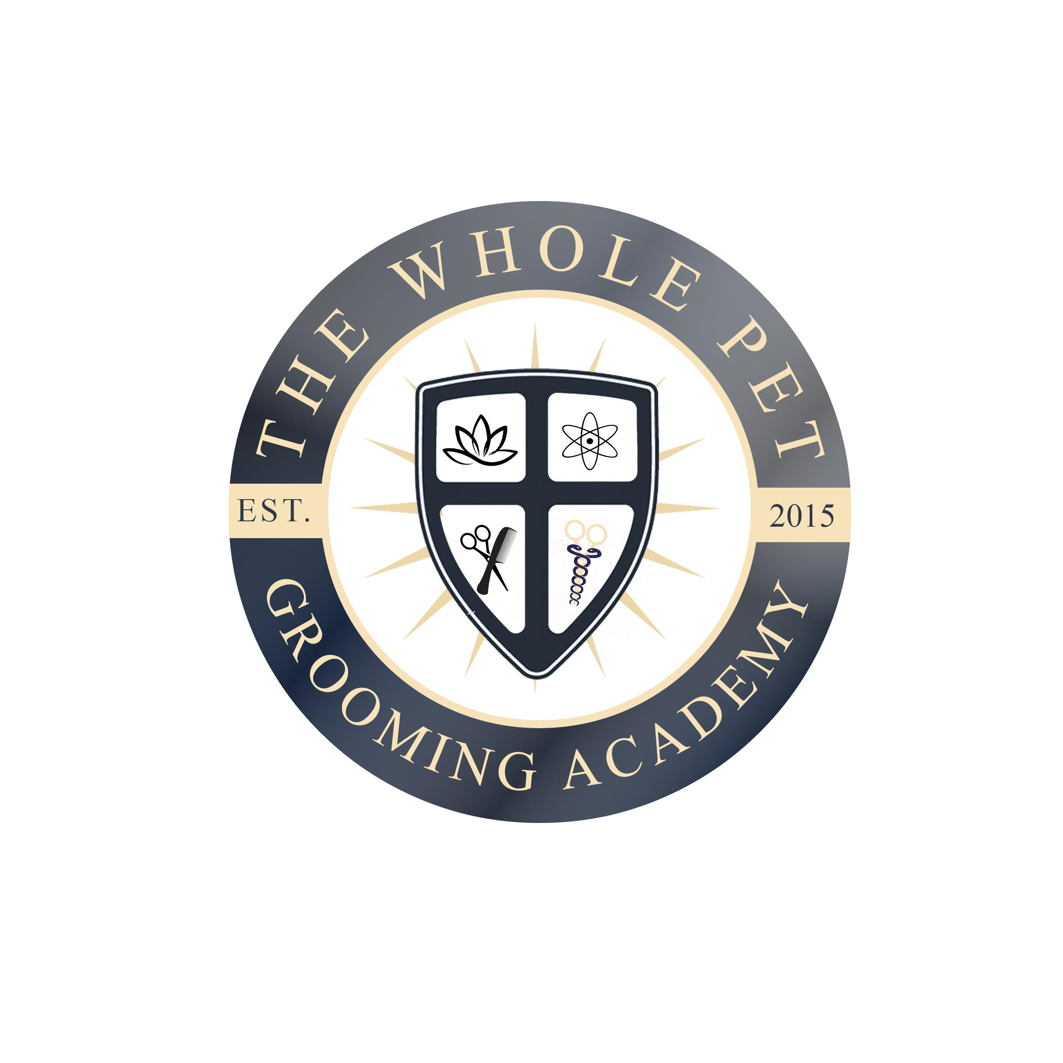

Welcome to The Whole Pet Grooming Academy

Enclosed you will find all necessary information for Animal Communication courses and Diploma.

Please let us know if you have additional questions, wish to schedule a tour or visit, or set up a zoom call interview for enrollment. Dara Forleo, Dean of Students

Student Disclosures Page 1

Fees and Information Page 2

Course Description
Page 2

Student Protection and Disclosures HEDC 304.1

Admission Requirements
Students must be at least 18 years of age with a high school degree or hold a GED.
Students under 18, with consent from guardians, will be considered on an individual basis, that have their high school degree or hold a GED.
Students do not need to have any prior experience with animals or pet grooming.
Students must complete an entrance exam to gauge knowledge, understanding and experience of the grooming industry. Not a graded exam.

Grading Scale
Students will be given technical and written/practical exams. Technicals are a pass/fail, based on mastery of the specific skills taught at the time, written/practical will be graded on a scale of A-F. Written/Practical exams must be passed with no less than a B- to move onto the next section of schooling.
If a student fails to meet the requirements of the set academic action plan they will be dismissed for not meeting academic satisfactory requirements.

Refund Policy
(1) All refunds shall be paid within 30 days upon written notification from a student of cancellation or withdrawal; and
(2) Students receiving benefits from federal programs shall be subject to federal refund policies, rules and regulations;

Transfer Credits
Students' past credits will be reviewed, but does not mean credits may be accepted.

Grievance Policy
Any student who has a grievance with the school or an instructor should make a written complaint and submit it to the school director. A response will be written within 3 to 5 days. If a satisfactory resolution of the problem is not obtained, the student may then contact: send a signed and dated letter to Division of Educator Support and Higher Education, Office of Career School Licensing, 101 Pleasant Street, Concord, NH 03301, Tel: (603) 271-6443.

Academic Calendar, Hours of Operation & Locations
The Whole Pet Grooming Academy operates on non-traditional terms. Office hours vary per instructor, 9:00-5:00 Monday-Friday hands on hours.
Federal holidays observed as listed, but not limited to:
New Year’s Eve, New Year’s Day, Martin Luther King Jr. Day, Easter, Memorial Day
Independence Day, Labor Day, Columbus Day, Veterans Day, Thanksgiving Day
Christmas Eve, Christmas Day

1 Robert Avenue Monadnock Canine Center
Portsmouth, NH 03801 604 Gibbons Hwy, Wilton, NH 03086
Contact info@wholepetnh.com Contact info@wholepetnh.com
603-801-5584

Fees and Information $150.00 one-time application fee applied, refundable within 3 days
Deposit $600.00 towards tuition of enrolled online diploma
Required book will need to be purchased separately
Finance charges may be applied with use of credit card or finance company Get a preapproval for financing at https://app.paypossible.com/m/wholepet/
Pay Per Course as you progress through the program

Course Pricing
*Basic Animal Communication 40 hours $2,400.00
*Advanced Animal Communication I 40 hours $2,400.00
*Advanced Animal Communication II 40 hours $2,400.00
*Death & Dying Animal Communication 25 hours $1,800.00
*Boundaries & Ethics 30 hours $1,800.00
Professional Animal Communicator 18 hours $1,080.00

Financing Options:
https://app.paypossible.com/m/wholepet/
Get your pre-approval at the link above.

Instructor Contact:
Latifa Meena email: latifa@wholepetnh.com
Website www.animalscantalk.com

Course Description:
Basic Animal Communication: 40 hours; This certified course is designed to allow students to learn the beginning basic skills needed to learn how to communicate with animals. Students will learn to create a baseline of how they learn. Practice with animals will be required during this course and students will use their own animals and others. Students will learn the skill sets required to work with animals of all breeds and species, living and crossed, as well as, how to work with the animal’s owners. This class will be delivered through alternative delivery of 4 videos 45 minutes in length covering the above listed topics.
Textbook includes: Learn Telepathy by Khwaja Shamsuddin Azeemi, Animal Talk by Penelope Smith, Communicating with Animals by Arthur Meyers

Advanced Animal Communication Part I: 40 hours; This certified course is designed to allow students to learn the beginning basic skills needed to learn how to communicate with animals. Students will learn to create a baseline of how they learn. Practice with animals will be required during this course and students will use their own animals and others. Students will learn the skill sets required to work with animals of all breeds and species, living and crossed, as well as, how to work with the animal’s owners. This class will be delivered through alternative delivery of 4 videos 45 minutes in length covering the above listed topics.
Textbook includes: Learn Telepathy by Khwaja Shamsuddin Azeemi, Animal Talk by Penelope Smith, Communicating with Animals by Arthur Meyers

Advanced Animal Communication Course Part II: 40 hours; This certified course will teach students how to stay safe during the animal communication process. Students will create a deeper connection with the animals they work with including different breeds and species. Practice with animals will be required during this course and students will use their own animals and others. Students will be required to present case study during this course. This class will be delivered through alternative delivery of 4 videos 45 minutes in length covering the above listed topics.
Textbook includes: Learn Telepathy by Khwaja Shamsuddin Azeemi, Animal Talk by Penelope Smith, Communicating with Animals by Arthur Meyers

Death and Dying for Animals: 25 hours; This certified course helps students to understand how animals view death and the dying process. Gain knowledge of the process from an animal’s point of view and understand their needs and wishes during the process. Students will also learn how to help their humans before and after the process. Practice with animals will be required during this course and students will use their own animals and others. Students will be required to present case study during this course. This class will be delivered through alternative delivery of 4 videos 45 minutes in length covering the above listed topics.
Textbook includes: Esoteric Healing by Alice Bailey

Boundaries and Code of Ethics: 30 hours; This certified course outlines the boundaries and code of ethics students need to follow when working as an animal communicator. These guidelines will keep students safe in this process and ensure their animal communication is a welcomed service providing a safe and comforting environment when engaging as an Animal Communicator. Practice with animals will be required during this course and students will use their own animals and others. This class will be delivered through alternative delivery of 4 videos 45 minutes in length covering the above listed topics.
Textbook includes: Animal Talk by Penelope Smith, Esoteric Healing by Alice Bailey

Professional Animal Communication: 18 hours; This certified course will enable students to bring together all of their skills and abilities. This course is only available when students have successfully completed the Basic Animal Communication, Advanced Animal Communication Part I and II, Death and Dying for Animals and Boundaries and Ethics as an Animal Communicator. Practice with animals will be required during this course during the hours.

